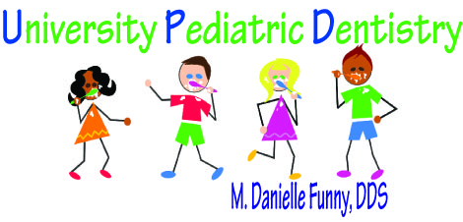
Post Pediatric Dental Treatment Instructions

- Local Anesthesia
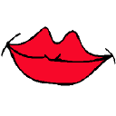
Your child may have a numb lip and/or cheek up to 2 hours after their dental visit. Please watch carefully for the next few hours to make sure your child does not bite, chew on or scratch his/her lip, cheek or tongue.

- Stainless Steel Crowns

Your child received a stainless steel crown (cap) today. There are certain foods that should be avoided to prevent the crown from being pulled off. Since the crown is cemented (glued) to the tooth your child should avoid sticky food and candies. (Ex. Gummy Bears, Fruit Roll-ups, Taffy, Tootsie Rolls, caramel and chewing gum) Children’s Motrin or Tylenol should be given immediately after the visit to prevent soreness.
- Extraction
- Have your child bite on gauze at the extraction site for 15 minutes
- Slight oozing is to be expected and may continue for several hours without need for alarm
- Feed your child soft foods on the day of the extraction
- No sucking on straws or spitting on the day of the extraction
- Children’s Motrin or Tylenol should be given immediately after their appointment and then as directed until bedtime. This is very important to prevent post-treatment pain!
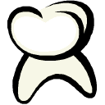
- Sealants or Fillings

Sealants are bonded to the biting surface of your child’s teeth. Sticky foods such as Gummy bears, Fruit Roll-ups, Taffy, Tootsie Rolls, caramels and chewing gum, etc may cause the sealant to become dislodged. Chewing on ice should also be avoided so the sealants can protect your child’s teeth for years to come!

Space Maintainer or Appliance
Space Maintainers or appliances are cemented (glued) to your child’s teeth. However, sticky foods such as Gummy bears, Fruit Roll-ups, Taffy, Tootsie Rolls, caramels and chewing gum, etc. may cause bands to become dislodged or distorted. Chewing on ice should also be avoided. Excellent oral hygiene is a must to properly maintain this appliance as well as your child’s oral health! If your child has discomfort today, Children’s Motrin or Tylenol may be given to ease their soreness.

2325 W. Arbors Drive, Suite 104 * Charlotte, NC 28262 * 704-688-1664

